- Tên và phân loại:

- Mục đích, ý nghĩa:
Provide a unified interface to a set of interfaces in a subsystem.
Facade defines a higher-level interface that makes the
subsystem easier to use
- Động lực sử dụng:
- Structuring a system into subsystems helps reduce complexity
- The interface exposed by the classes in a subsystem or set of subsystems can
become quite complex
- One way to reduce this complexity is to introduce a facade object that
provides a single, simplified interface to the more general facilities of a subsystem
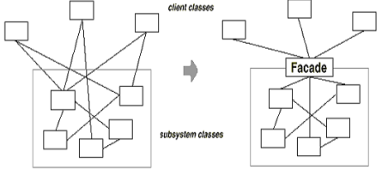
- Khi nào sử dụng:
- You want to provide a simple interface to a complex subsystem
• Subsystems often get more complex as they evolve.
• Most patterns, when applied, result in more and smaller classes.
• This makes the subsystem more reusable and easier to customize, but it also becomes harder to use for clients that don't need to customize it.
• Provide a simple default view of the subsystem that is good enough for most clients. Only clients needing more customizabilitywill need to look beyond the facade.
- There are many dependencies between clients and the implementation classes of an abstraction
• Introduce a facade to decouple the subsystem from clients and other subsystems, thereby promoting subsystem independence and portability.
- Cấu trúc
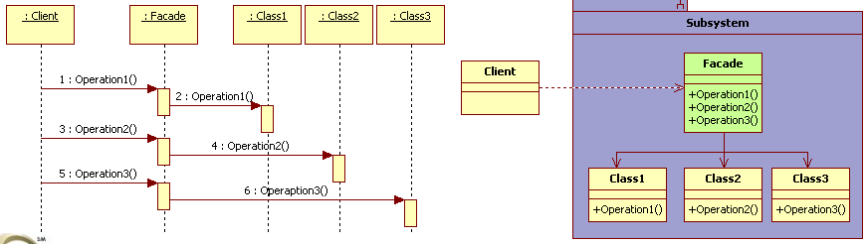
- Các thành viên - Sự cộng tác
- Facade
• knows which subsystem classes are responsible for a request
• Delegates client requests to appropriate subsystem objects
- Subsystem Classes
• Implement subsystem functionality
• Handle work assigned by the Facade object
• Have no knowledge of the facade; that is, they keep no
references to it

- Các hệ quả mang lại:
- Shields clients from subsystem components, thereby reducing the number of objects that clients deal with and making the subsystem easier to use.
- Promotes weak coupling between the subsystem and its clients:
• Often the components in a subsystem are strongly coupled. Weak coupling lets you vary the components of the subsystem without affecting its clients
• Help layer a system and the dependencies between objects. They can eliminate complex or circular dependencies. This can be an important consequence when the client and the subsystem are implemented independently.
- Doesn't prevent applications from using subsystem classes if they need to. Thus you can choose between ease of use and generality.
- Chú ý liên quan đến cài đặt:

- Hệ thống thực tế

- Mẫu liên quan
- Abstract Factory can be used with Facade to provide an interface for creating subsystem objects in a subsystem-independent way.
Abstract Factory can also be used as an alternative to Facade to hide platform-specific classes.
- Mediator is similar to Facade in that it abstracts functionality of existing classes. However, Mediator's purpose is to abstract arbitrary communication between colleague objects, often centralizing functionality that doesn't belong in any one of them. A mediator's colleagues are aware of and communicate with the mediator instead of communicating with each other directly. In contrast, a facade merely abstracts the interface to subsystem objects to make them easier to use; it doesn't define new functionality, and subsystem classes don't know about it.
- Usually only one Facade object is required. Thus Facade objects are often Singletons.

